Treating Patuas fairly. Code of Ethics and Practical Guidelines for galleries, event organisers, museums, publishers and the media.

This is a copy of the 2019 calendar published for the Apex Club of Bally. The Apex Club of Bally is an NGO that works with the aged and elderly on health and welfare issues. The calendar features a number of Patachitra images painted by patuas from Pingla village in West Midnapore. The images were gathered from an exhibition put together for the Apex Club to celebrate the talents of the Patachitraartists and their traditions.

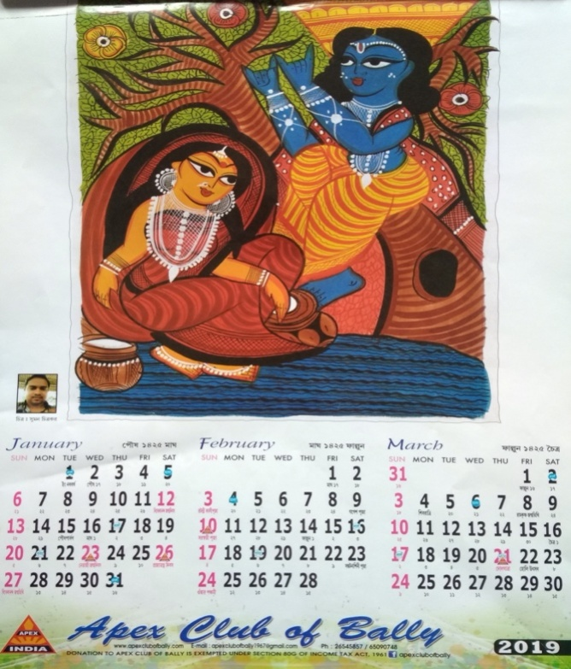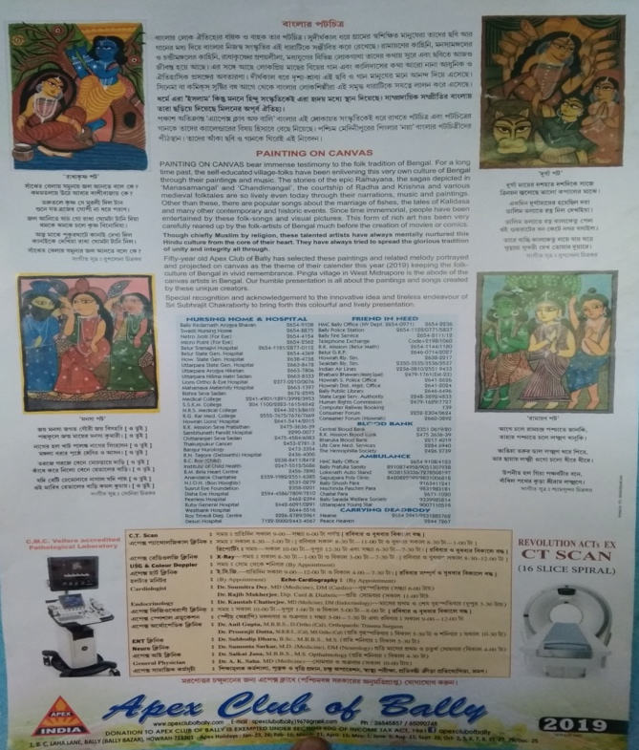
Reproduced with kind permission of Suman Chitrakar XXXXXXXXXX
Copyright in Photograph Banglanatak dot com

The image on the left hand side was painted by Suman Chitrakar from Pingla. This is also reproduced on the page of the calendar which gives information about the paintings and artists, shown in the image on the right hand side. Suman’s name and his photograph appear next to his painting. Suman is delighted that the Apex Club chose to showcase Patachitra created by artists from Pingla for their 2019 calendar. However, neither he nor his fellow artists were asked for permission to reproduce their paintings in this way. In other words, the publisher of the calendar and the Apex Club reproduced the paintings without his, or his fellow artists, permission.

Laws in India (on copyright, image rights and performers rights) give Patuasthe right to stop people copying their paintings and recording their songs and distributing copies of these without their permission or acknowledgement. However, these laws can be difficult to understand and enforce, and many unethical practices continue.
So, the Patuas developed this Code with the HIPAMS team to explain what their rights are, and how they would like to interact with other stakeholders, such as galleries, event organisers, museums and publishers
Patachitra heritage / art code

We produce beautiful, meaningful patachitra art as part of a tradition of storytelling and performance that stretches back over hundreds of years. Patachitra in West Bengal and Odisha have been recognised as Indian handicraft through Craftmark. They have also been granted Geographical Indications, protecting use of the names Bengal Patachitra and Odisha Patachitra.
However:
- Some of our art is copied by others
- Some art is sold as Bengal/ Odisha Patachitra, but it does not come from tradition bearers
- Some of our artists do not get paid fairly for our work
What we would like:
- We would like to keep making patachitra art now and in the future according to our traditions
- We would like to keep composing songs for storytelling on diverse themes
- We would like people to know about and respect our tradition of patachitra
- We would like to make sure that people who buy our art know where it comes from
- We would like others not to copy our art unless we give them permission to do so
- We would like to be paid fairly for our art
- We would like to have share of benefits from any use of our art
- We would like to be treated with respect
People who buy and use our art in homes, shops, galleries, festivals, events and museums can help us by:
- Respecting and understanding our art and tradition
- Telling people where the art comes from
- Telling people about the meaning and value of our art as part of our cultural heritage
- Not copying or allowing copying of our art unless we give permission to do so
- Understanding, respecting and explaining to others the use of the Geographical Indication on our products
People who do research, report for the media or make films and television programmes involving Patachitra can help us by:
- Treating us with respect
- Respecting the heritage of Patachitra
- Telling people about the meaning and value of our Patachitra heritage
- Consulting and involving us in projects about our lives and work
- Paying us fairly for our art and performances
- Attributing us and acknowledging our contributions in books, films, and other products they create.

Annex: Foundational principles
These have been adapted from the UNESCO Intangible Heritage Convention’s Ethical Principles (2015)
- Intangible cultural heritage is practised and transmitted in accordance with the principles of human rights, respect for the environment and mutual respect between people.
- Communities (including groups and, where applicable, individuals) decide what their intangible cultural heritage is, and its meaning and value.
- Communities play the main role in safeguarding their own intangible cultural heritage, and should be supported appropriately in doing so.
- Mutual respect for communities and their intangible cultural heritage should guide all activities for intangible cultural heritage safeguarding.
- Safeguarding activities should be undertaken with the participation, and free, prior and informed consent of the communities concerned.
- Communities should be involved through collaboration, dialogue, negotiation and consultation in safeguarding their intangible cultural heritage.
- Community requirements for secrecy and privacy in regard to their intangible cultural heritage should be respected.
- Communities should have continued access to the instruments, objects, artefacts, cultural and natural spaces and places of memory they need for expressing their intangible cultural heritage.
- Communities should be recognised and attributed appropriately for works based on their intangible cultural heritage, and protected from decontextualization, commodification and misrepresentation, according to their needs.
- Communities should benefit from the moral and material interests resulting from their intangible cultural heritage, including when it is used and adapted by members of the communities or others.
- Communities should be able to share fairly in the benefits from safeguarding, practising and transmitting their intangible cultural heritage.

